**Setup monitoring on EKS Cluster using Prometheus and Grafana**

### Key components:

    1. Prometheus server - Processes and stores metrics data

    2. Alert Manager - Sends alerts to any systems/channels

    3. Grafana - Visualize scraped data in UI

### Installation Method

The are are many ways you can setup Prometheus and Grafana. You can install in following ways:

1. Create all configuration files of both Prometheus and Grafana and execute them in right order.

2. Prometheus Operator - to simplify and automate the configuration and management of the Prometheus monitoring stack running on a Kubernetes cluster

3. Helm chart (Recommended) - Using helm to install Prometheus Operator including Grafana

# Prerequisites

* [Kubernetes](https://www.coachdevops.com/2022/02/create-amazon-eks-cluster-by-eksctl-how.html) cluster is setup already
* [Install Helm](https://www.coachdevops.com/2021/03/install-helm-3-linux-setup-helm-3-on.html)
* EC2 instance to access EKS cluster

#### Implementation steps

# We need to add the Helm Stable Charts for your local client. Execute the below command:

helm repo add stable https://charts.helm.sh/stable



# Add prometheus Helm repo

helm repo add prometheus-community <https://prometheus-community.github.io/helm-charts>



helm search repo prometheus-community

* Prometheus and grafana helm chart moved to kube prometheus stack

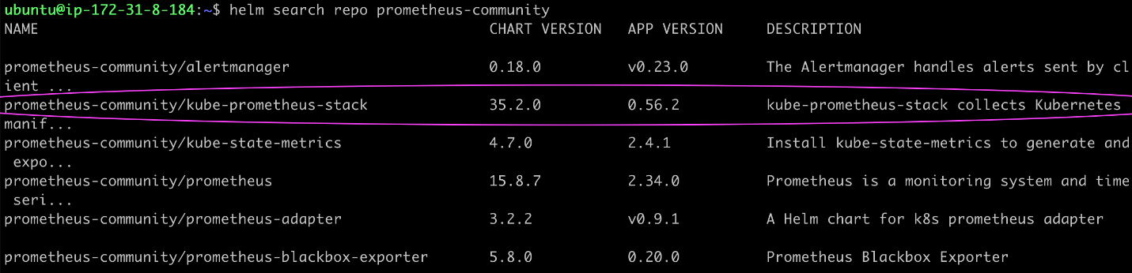

# Create Prometheus namespace

kubectl create namespace prometheus



# Below is helm command to install kube-prometheus-stack. The helm repo kube-stack-prometheus (formerly prometheus-operator) comes with a grafana deployment embedded.

helm install stable prometheus-community/kube-prometheus-stack -n Prometheus

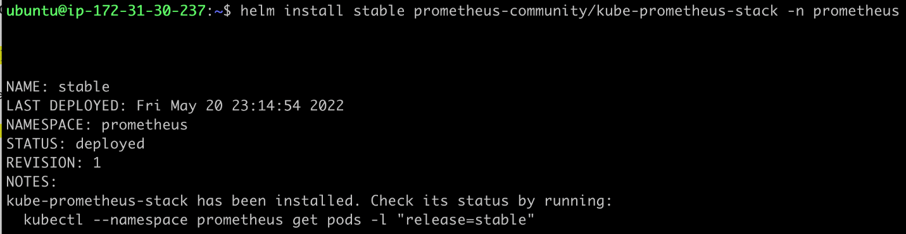

# Lets check if prometheus and grafana pods are running already

kubectl get pods -n Prometheus

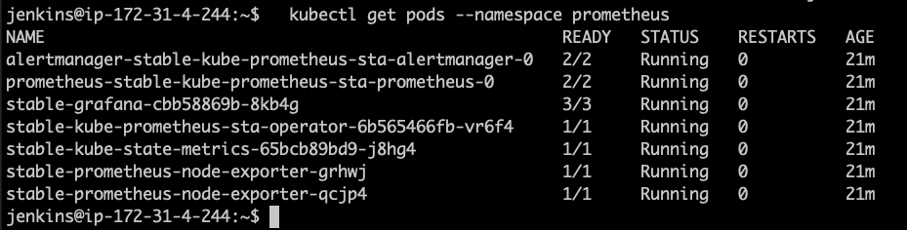

kubectl get svc -n Prometheus

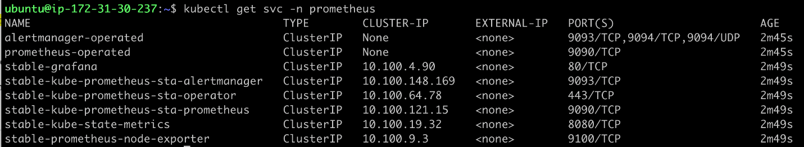

This confirms that prometheus and grafana have been installed successfully using Helm.

# In order to make prometheus and grafana available outside the cluster, use load balancer or NodePort.

#### Edit Prometheus Service

kubectl edit svc stable-kube-prometheus-sta-prometheus -n Prometheus

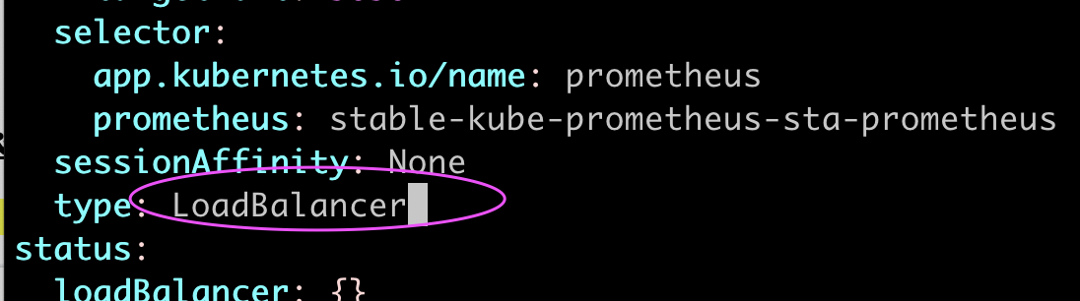

#### Edit Grafana Service

kubectl edit svc stable-grafana -n Prometheus

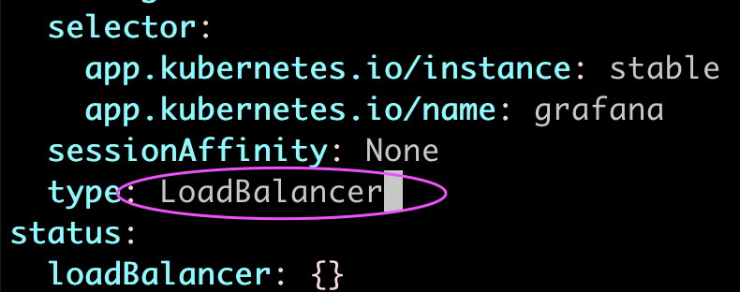

# Verify if service is changed to LoadBalancer and also to get the Load Balancer URL.

kubectl get svc -n Prometheus

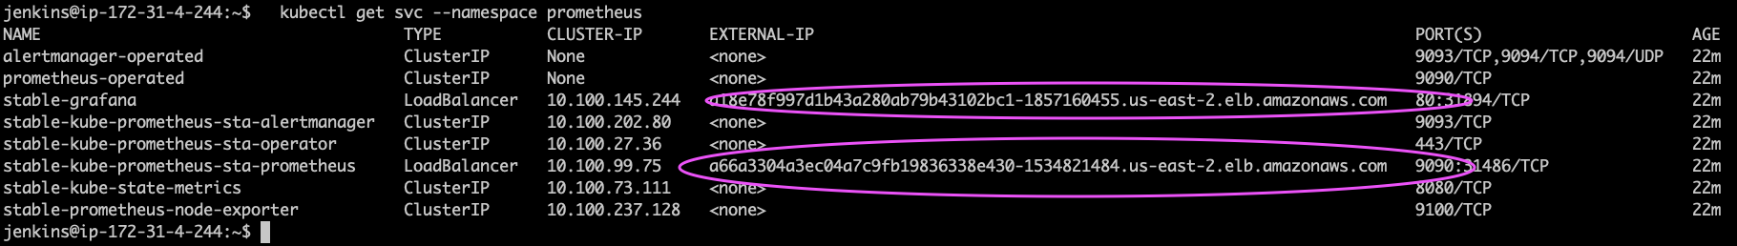

**Access Grafana UI in the browser**

Get the URL from the above screenshot and put in the browser

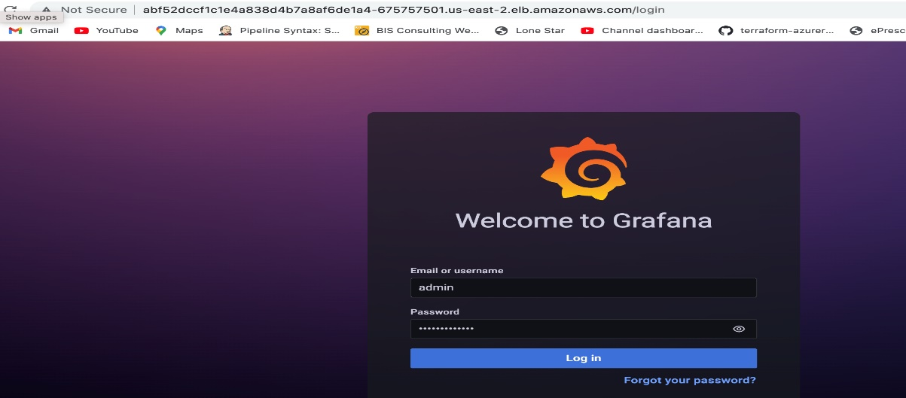

UserName: admin

Password: prom-operator

**# Create Dashboard in Grafana**

In Grafana, we can create various kinds of dashboards as per our needs.

For creating a dashboard to monitor the cluster:

Click '+' button on left panel and select ‘Import’.

Enter 12740 dashboard id under Grafana.com Dashboard.

Click ‘Load’.

Select ‘Prometheus’ as the endpoint under prometheus data sources drop down.

Click ‘Import’.

This will show monitoring dashboard for all cluster nodes

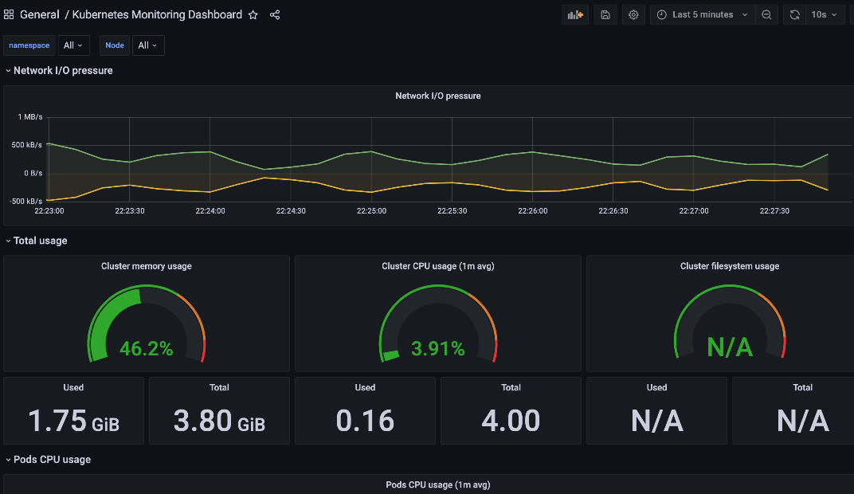

**How to Create Kubernetes Cluster Monitoring Dashboard?**

For creating a dashboard to monitor the cluster:

Click '+' button on left panel and select ‘Import’.

Enter 3119 dashboard id under Grafana.com Dashboard.

Click ‘Load’.

Select ‘Prometheus’ as the endpoint under prometheus data sources drop down.

Click ‘Import’.

This will show monitoring dashboard for all cluster nodes

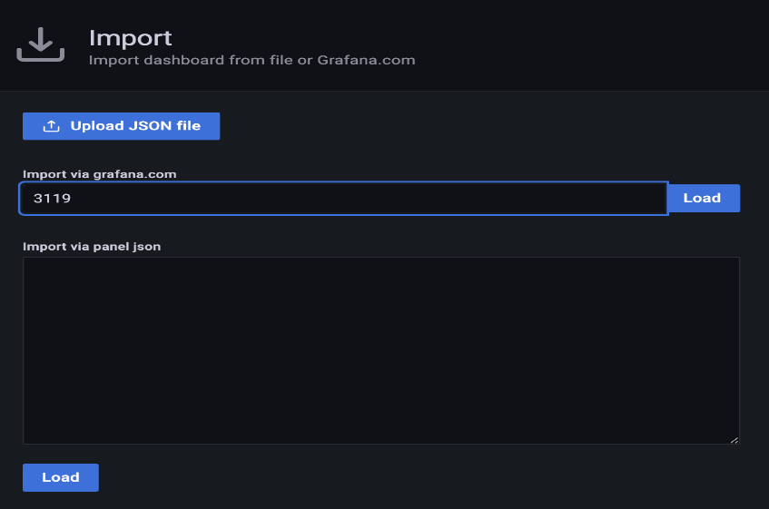

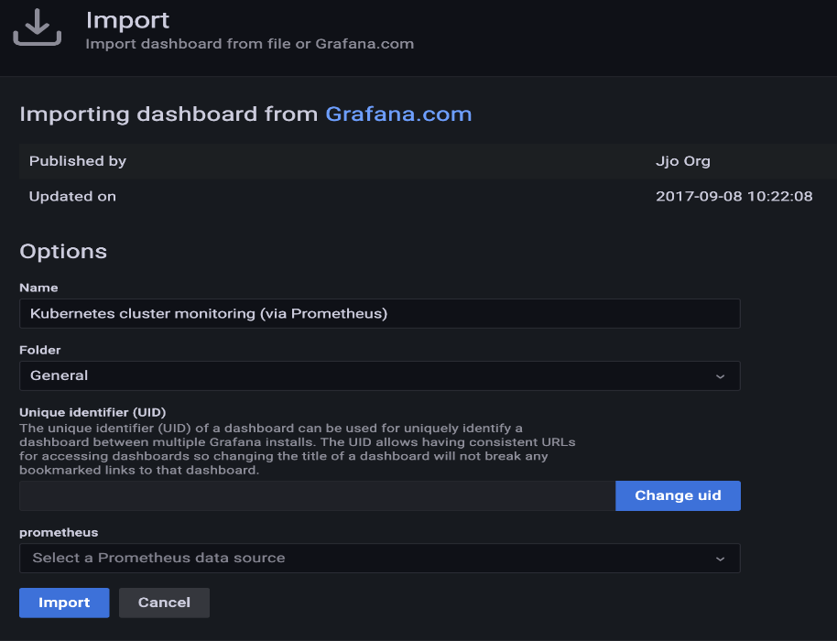

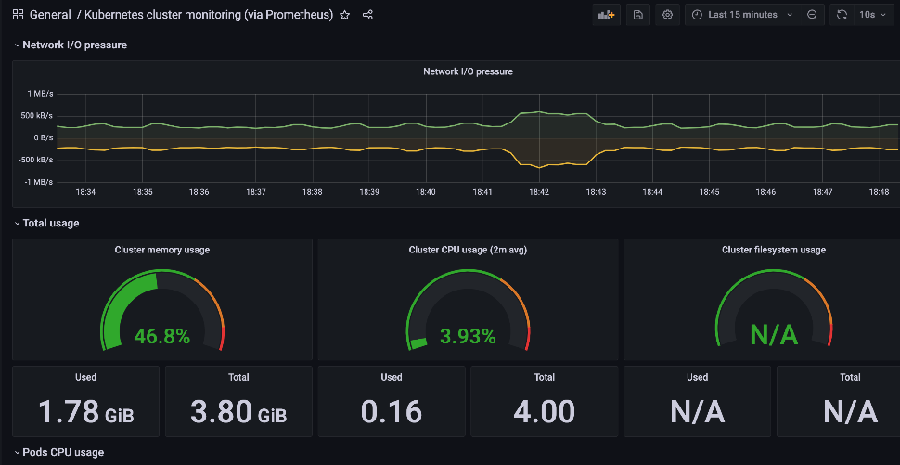

## # Create POD Monitoring Dashboard

For creating a dashboard to monitor the cluster:

Click '+' button on left panel and select ‘Import’.

Enter 6417 dashboard id under Grafana.com Dashboard.

Click ‘Load’.

Select ‘Prometheus’ as the endpoint under prometheus data sources drop down.

Click ‘Import’.

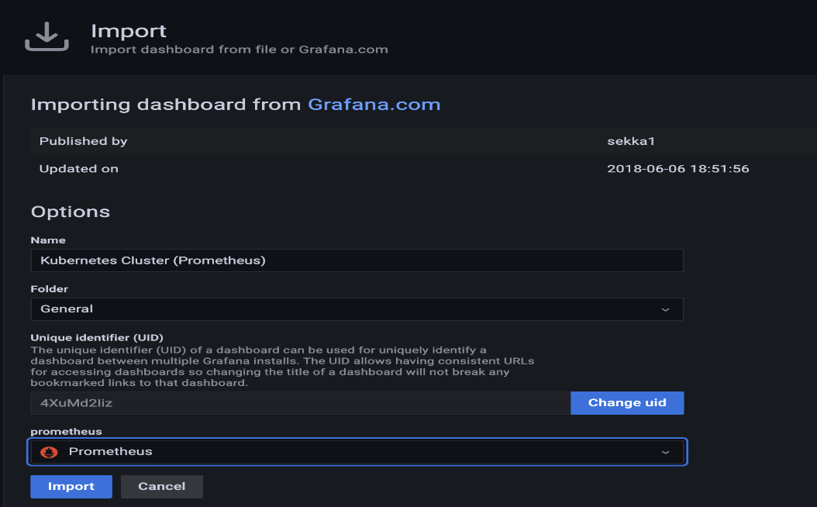

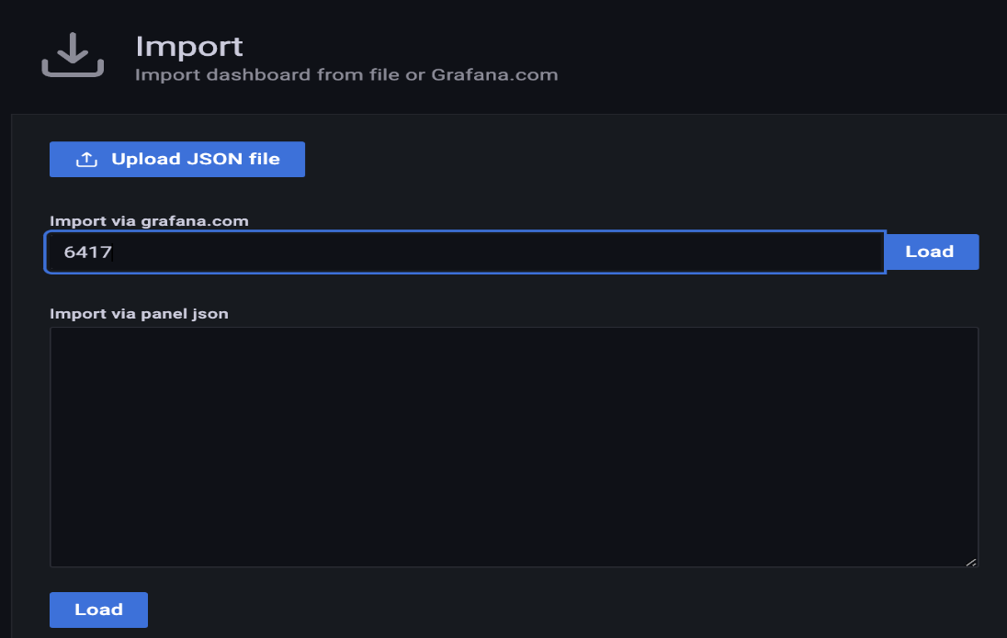

This will show monitoring dashboard for all cluster nodes.

